Source https://www.getyourguide.com/paris-l16/paris-eiffel-tower-tour-and-seine-cruise-t430766/?ranking_uuid=2d1eceb9-9b48-4dbf-8c14-ff0dc3ba1d68
__________________________________________________________

Paris Prestige Experience: Eiffel Tower Guided Access & Seine River Cruise
__________________________________________________________
★★★★★ 4.5/5 20 reviews

Add to wishlist ♡

__________________________________________________________

3 Hours | €110 per person

🏕  Image | 🏕  Image | 🏕  Image | 🏕  Image | 🏕  Image | 🏕  Image

__________________________________________________________
Experience Overview
Discover the magic of Paris through a perfectly combined experience featuring a guided visit to the Eiffel Tower and a scenic cruise along the Seine. This immersive activity blends panoramic city views, fascinating historical insights, and a relaxing river journey past some of the capital’s most iconic landmarks. Designed for travelers who want to see Paris from above and from the water, it delivers a memorable introduction to the City of Lights.
__________________________________________________________
Tour Snapshot
- Duration: 3 hours
- Meeting Point: 62 Avenue de Suffren, 75015 Paris, France
- Group Size: Standard tour group
- Accommodation: Not included (activity experience only)
- Languages Available: English
- Private Guide: Not included
- Transportation: Not included
- Season: Available year-round
__________________________________________________________

Check Dates & Availability

Select participants: (Age 99 and younger) - 1 +

Choose date:
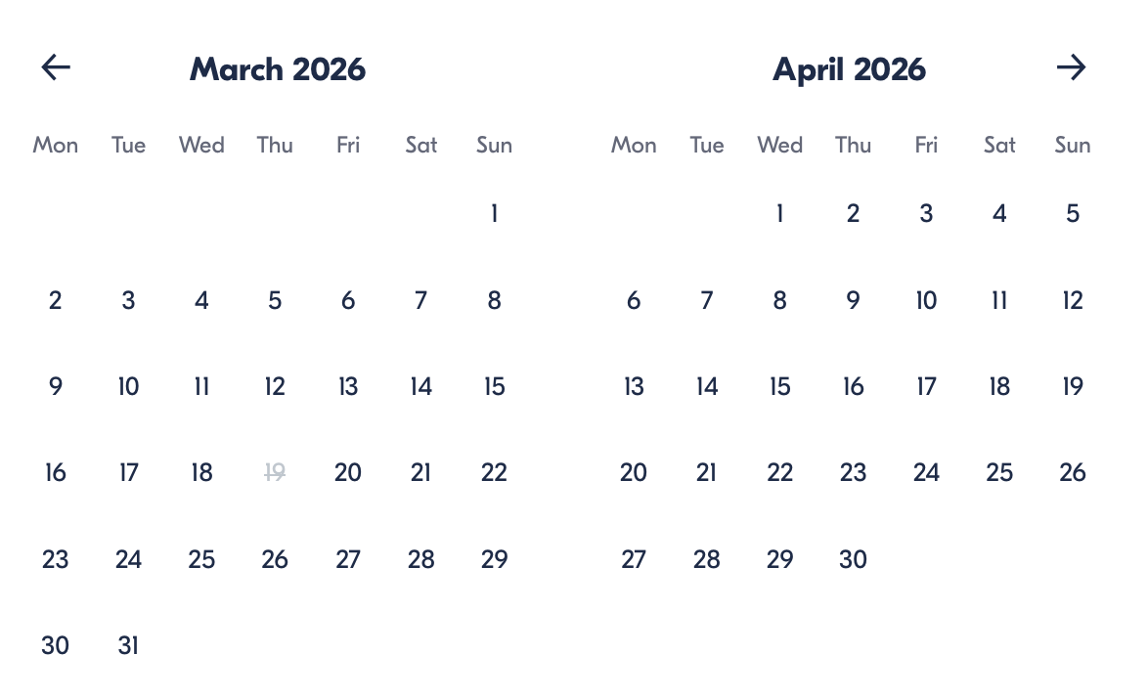

Check Availability

opens:

Participants: 1 March 16, 2026

Paris Prestige Experience: Eiffel Tower Guided Access & Seine River Cruise

- Duration: 3 hours
- Offered in: English
- Starts at: 7:30 PM

Cancellation:

- More than 24 hours before start: Full refund
- 24 hours or less before start: No refund

Price breakdown: 1 Participant x €110

Total: €110

The total price includes all taxes and fees.

Add to cart Book now

__________________________________________________________
Tour Snapshot
- Duration: 3 hours
- Meeting Point: 62 Avenue de Suffren, 75015 Paris, France
- Group Size: Standard tour group
- Accommodation: Not included (activity experience only)
- Languages Available: English
- Private Guide: Not included
- Transportation: Not included
- Season: Available year-round
__________________________________________________________
Full Experience Description
Begin your Parisian evening by meeting your guide near the Eiffel Tower before heading inside for your guided visit. During this immersive exploration, your guide shares stories about the monument’s design, engineering, and cultural significance while you ascend by elevator to your selected viewing level.
From above, admire breathtaking perspectives across Paris, spotting famous landmarks such as the Arc de Triomphe and Sacré-Cœur while enjoying the city’s elegant skyline.
After your tower visit, continue your experience with a tranquil river cruise along the Seine. Glide past historic architecture, legendary bridges, and celebrated riverside landmarks, including Notre Dame, Les Invalides, and the Conciergerie. With flexible timing for the cruise, you can choose when to sail and tailor the evening to your schedule.
__________________________________________________________
Included in Price
- Entry ticket to Eiffel Tower (summit + second level OR second level only, depending on option)
- Guided Eiffel Tower tour in English
- 1-hour Seine River cruise with audio commentary
- All taxes and booking fees
__________________________________________________________
Not Included
- Transportation to the meeting point
- Food and drinks
- Gratuities
__________________________________________________________
Who Should Avoid This Tour
- Travelers using wheelchairs
- Visitors with significant mobility limitations
__________________________________________________________
Important Experience Info
Security & Entry
- Security and elevator lines may be required, especially during peak hours.
- Summit access requires an additional queue from the second floor.
Weather Preparation
- Viewing platforms can be windy and cold in winter.
- In summer, sun protection and water are recommended.
Timing Notes
- The tour ends at the Eiffel Tower.
- Leaving the tower by elevator may take 20–30 minutes.
- The Seine cruise can be taken anytime after the tower visit.
- Last cruise departure is around 10:30 PM, depending on the season.
Restrictions
Items not allowed inside:
- Large luggage
- Glass items
- Non-folding strollers
- Sharp objects or weapons
- Padlocks
- Umbrellas
Children Policy
Infants aged 0–3 must hold a paid seat ticket.
__________________________________________________________

Cancellation Policy

- Cancel more than 24 hours before start → Full refund
- Cancel within 24 hours or no-show → No refund

__________________________________________________________
What Our Clients Are Saying

Overall rating  4.5/5  ★★★★★  Based on 20 reviews | Review summary  Guide 4.5/5  Transportation 4.6/5  Service 4.7/5  Organisation 4.5/5

Filter  - All traveller types  - Couples  - Group of friends  - Families  By star rating  - All star ratings  - 5 stars  - 4 stars  - 3 stars  - 2 stars  - 1 star | Search reviews (e.g., guide)  Sort by:  - Top picks  - Latest reviews  - Best ratings  - Lowest ratings
__________________________________________________________
★★★★★
Natalia M. — Spain
The guide made the Eiffel Tower visit incredibly interesting, and the views at sunset were unforgettable. The cruise afterward felt magical.
★★★★★
Daniel K. — Canada
Everything was smooth and well-organized. Seeing Paris from above and then from the river was the perfect combination.
★★★★★
Claire B. — France
Wonderful experience! The explanations were fascinating, and the cruise was beautifully relaxing.
★★★★☆
Marcus T. — Germany
Great tour overall. Lines were a bit long, but the guide handled everything professionally.
See more reviews
__________________________________________________________

Meta tags

Page - Paris Prestige Experience: Eiffel Tower Guided Access & Seine River Cruise

Title: Paris Prestige Experience: Eiffel Tower Guided Access & Seine River Cruise | Travellio Global

Description: Discover Paris from two breathtaking perspectives with a guided Eiffel Tower visit and scenic Seine River cruise. Skip the stress and enjoy a seamless evening experience with panoramic views and iconic landmarks.

H1 - Paris Prestige Experience: Eiffel Tower Guided Access & Seine River Cruise
__________________________________________________________

